IPM Decisions
Stakeholder’s behaviour regarding the use of Decision Support Systems
A preliminary picture from WP5 data and WP6 workshops on IPM Decisions

Prepared by

Prof. N. Georgantzis, Dr. JC Tisserand and PhD (cand.) J Akaka

(Burgundy School of Business, France)

Contents
Introduction 2
Have you already used DSS? 2
Which would be your preferred way to access a DSS, and would you need additional computer-related education? 3
Do you prefer a graphical or textual output from a DSS? 4
Summary analysis 5
Appendix – Sample of responses collected in stakeholder workshops 6

Introduction

In the framework of the IPM Decisions project, workshops were held across the 12 participating countries across Europe between December 2019 and February 2020. IPM stakeholders were invited to participate in the workshops, during which they were asked to complete a questionnaire. This questionnaire was created in three different but comparable formats, adapted to the specificities of three groups of IPM stakeholders; farmers, farmer advisors, and decision support system (DSS) developers. A total of N=380 survey responses were collected from 16 workshops across 12 countries in Europe (Appendix 1, Table A1). Parallel to this, an online version of the questionnaire has been prepared and is currently used to increase the size of the sample: https://www.ipmdecisions.net/news/online-ipm-decisions-questionnaires/.
Here, we summarize some of the most interesting messages we have so far extracted from the survey responses.

Have you already used DSS?

The most interesting finding is that in the overall sample of potential users, more than half had never used a DSS (Figure 1). This clearly indicates that there is great potential for IPM Decisions to improve awareness of, and access to DSS, leading to higher levels of DSS adoption.

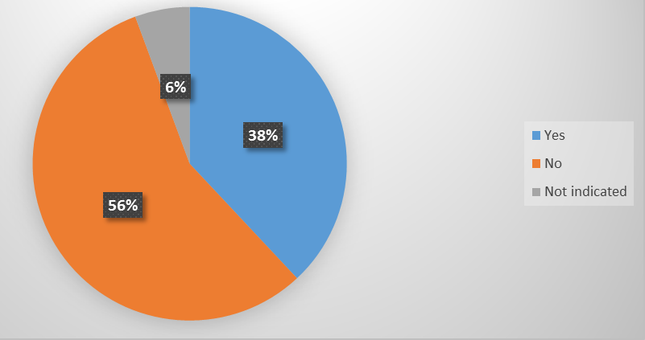

Figure 1: Percentage of farmers who have already used a DSS.

Which would be your preferred way to access a DSS, and would you need additional computer-related education?

Perhaps surprisingly, the current preferred route to access a DSS is via mobile phones (Figure 2), while most existing DSS are PC software or applications not easily accessible on mobile phone. Ensuring that DSS are readily accessible via a mobile phone is therefore likely to improve the number of farmers using them. Furthermore, over 80% of those who completed the questionnaire recognized that they would need further computer education, either urgently (9%) or, if that were available (72%; Figure 3).

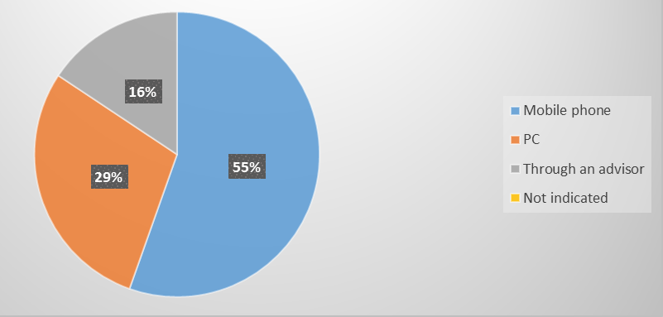
Figure 2: Percentages of farmers by preferred way of accessing a DSS

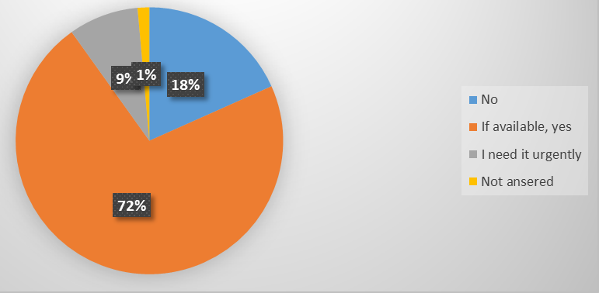
Figure 3: Farmers’ self-reported need for further computer-related education

Do you prefer a graphical or textual output from a DSS?
Finally, the existence of graphical output seems to be preferred, either exclusively (28%) or in combination with text (61%), while textual output alone is preferred by a small minority (7%) of (potential) users.

Figure 4: Farmers’ preferences regarding the interface (output) of a DSS.

Summary analysis

Further statistical analysis highlighted the following patterns regarding farmers and developers:

FARMERS:
- Access to high-speed internet increases the likelihood of a farmer using a DSS.
- The larger the farm size, and the more integrated a farm is, the more likely it is that a DSS is used.
- Farmers who are older and those who specialize in flowers are more likely to use a DSS.
- Farmers who prefer graphical (either exclusively or in combination with text) output from DSS are more likely to be using a DSS.

DEVELOPERS:
- Older developers of DSS are more critical, being less likely to consider them good enough.
- Developers of DSS will consider them generally useful if their own DSS is appropriate for use by both farmers and consultants, if it goes through frequent innovative upgrading, if it is suitable for orchards, and, in general, if they find them to fit the farmers’ needs.
- Finally, developers who are sceptical with the overall usefulness of DSS are also the ones who feel that price is not a reason for non-adoption.

Work on this dataset, along with future datasets collected in the next round of workshops in 2020/21, will help us to understand better the drivers behind DSS (non) adoption. This will allow us to optimise the design of the IPM Decisions platform and user interfaces. It will also support development of strategies for improving adoption of DSS across Europe, promoting sustainable and efficient IPM.

Appendix: – Sample of responses collected in stakeholder workshops

Table A1: Number of questionnaire responses collected in workshops by country and stakeholder type
No. | Country/workshop | Farmers | Developers | Agronomists | Total per country
1 | France (Chambres d'Agriculture Bretagne) | 10 | 1 | 5 | 16
2 | France (Tarn & Garonne) | 6 | 0 | 2 | 8
3 | Greece/1st Workshop | 10 | 3 | 12 | 25
4 | Greece/2nd Workshop | 10 | 2 | 10 | 22
5 | Norway | 0 | 5 | 5 | 10
6 | Lithuania | 9 | 4 | 7 | 20
7 | Denmark | 4 | 9 | 5 | 18
8 | Italy | 37 | 6 | 24 | 67
9 | Slovenia (Maribor) | 8 | 4 | 6 | 18
10 | Slovenia (Ljubljana) | 6 | 16 | 10 | 32
11 | United Kingdom | 11 | 10 | 15 | 36
12 | Sweden (Alnarp) | 5 | 3 | 4 | 12
13 | Sweden (Skara) | 6 | 3 | 9 | 18
14 | Finland | 10 | 4 | 10 | 24
15 | Germany | 9 | 8 | 17 | 34
16 | Holland | 5 | 5 | 10 | 20
 | Total per respondent type | 146 | 83 | 151 | 380

